- WIFI configuration:
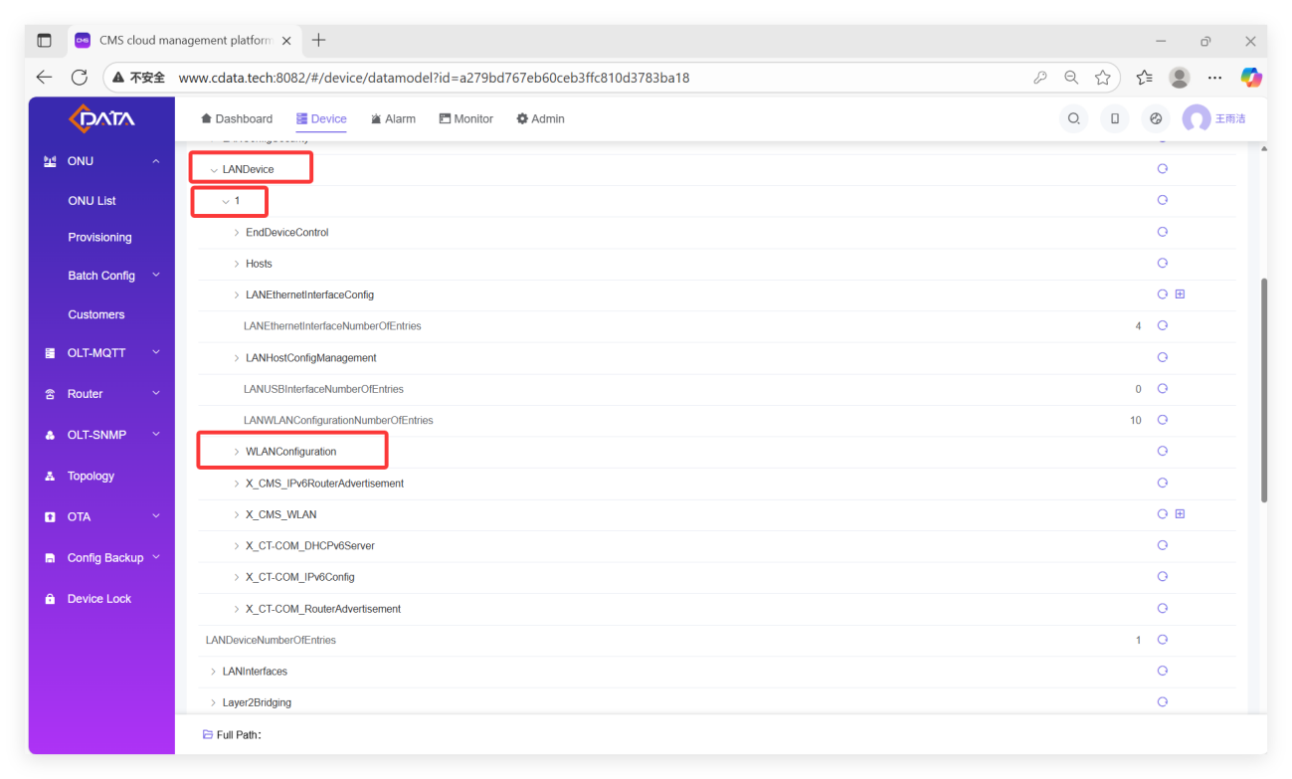
1. SSIDs 1-10, of which 1-4 are 5G SSIDs and 6-9 are 2.4G SSIDs
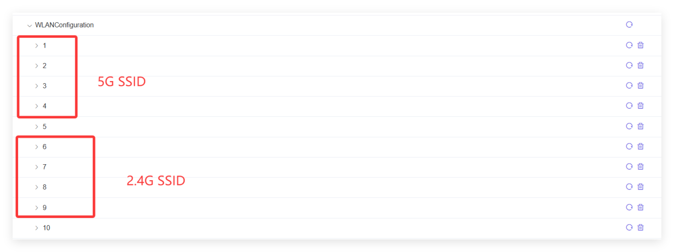
- Modify SSID account password
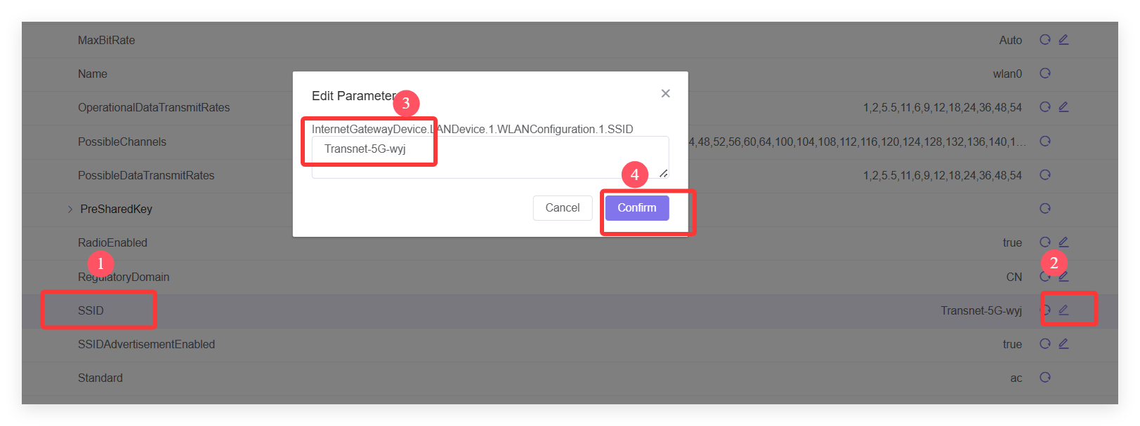
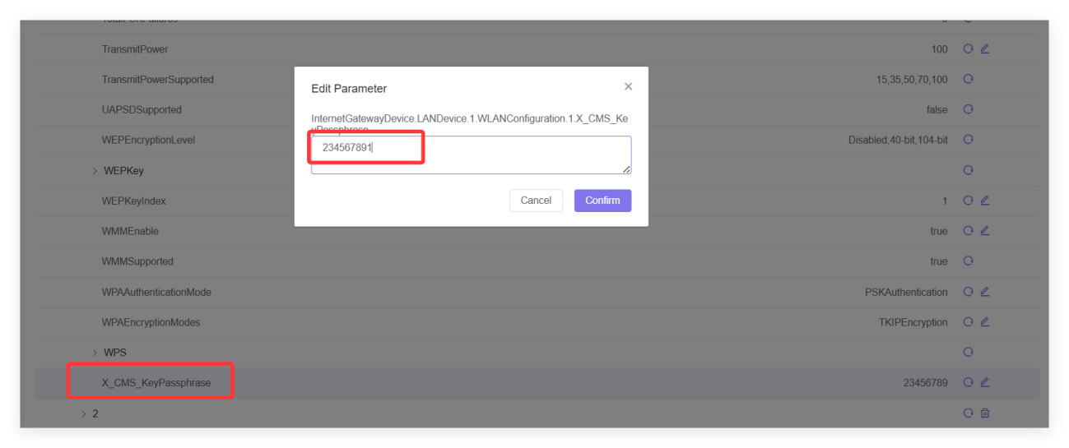
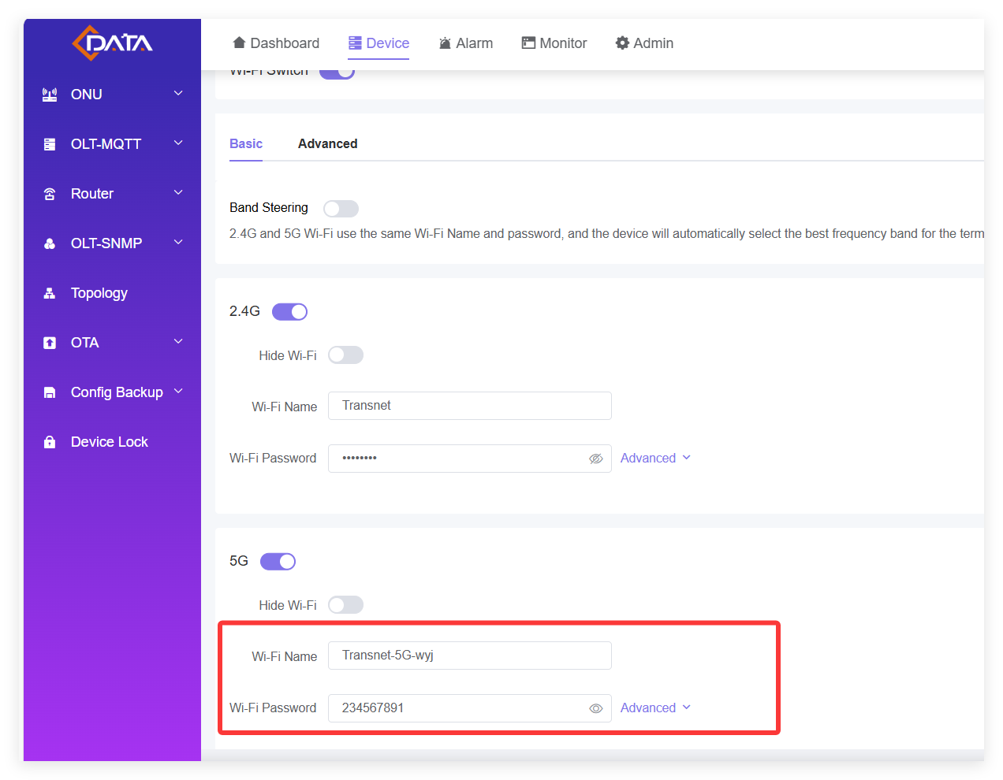
- Modify the channel: Before modifying, you need to configure AutoChannelEnable to false; then click channel to configure
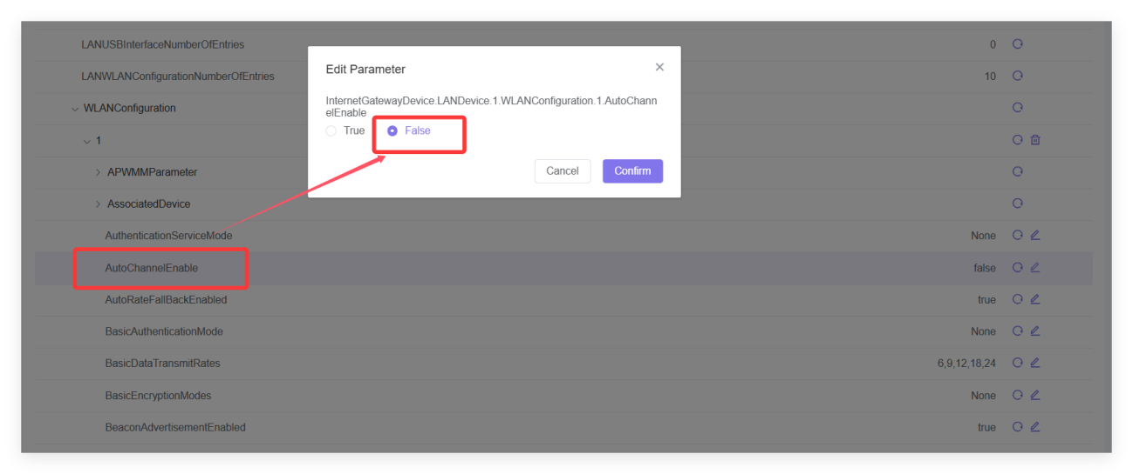
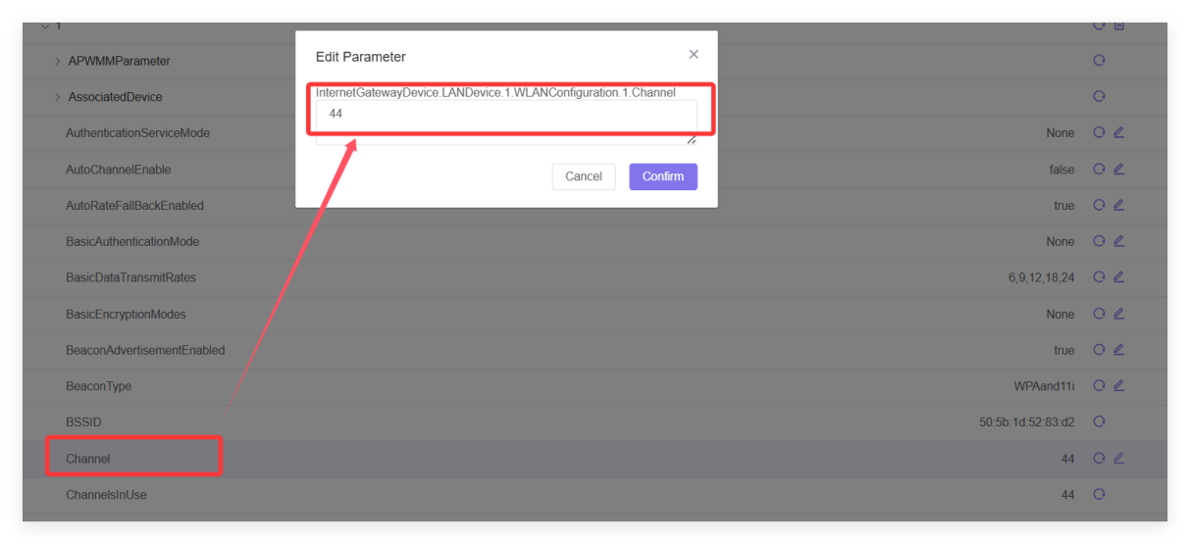
- Check available channels and operating modes: ac indicates a/n/ac
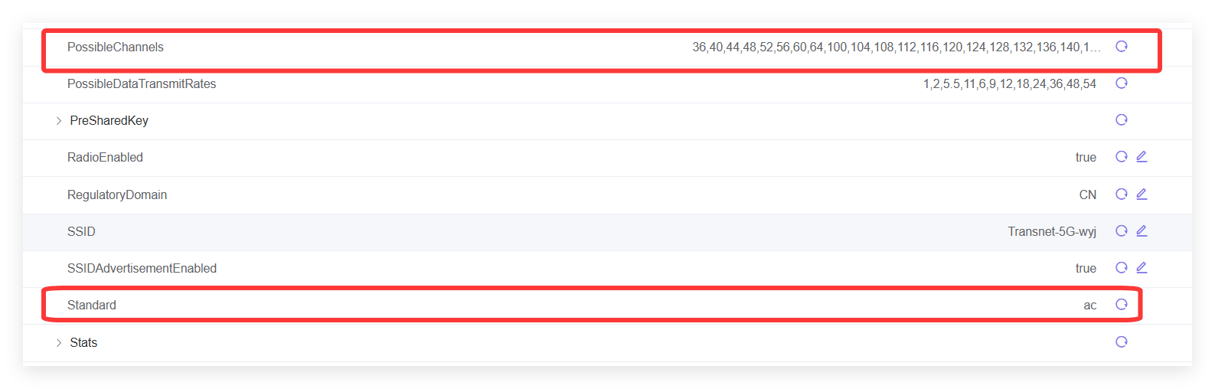
5. Enable dual-band integration
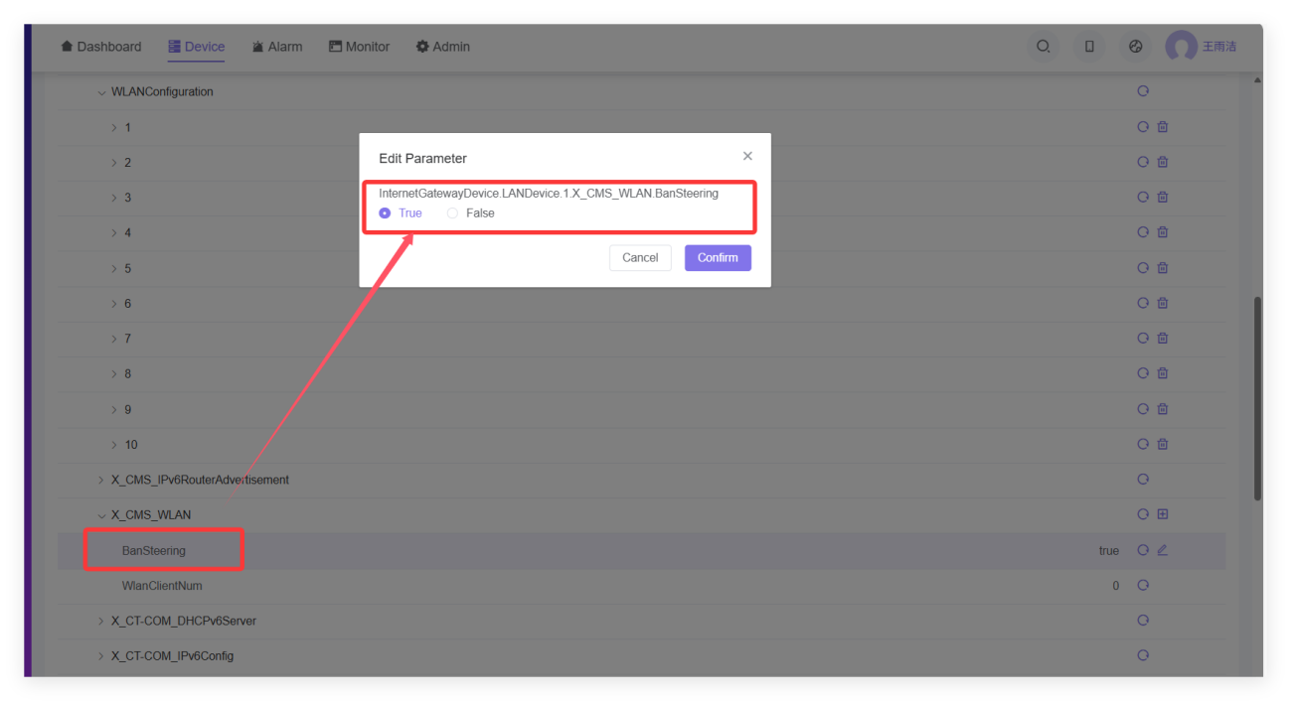

- WAN configuration:
- Create a new WAN:
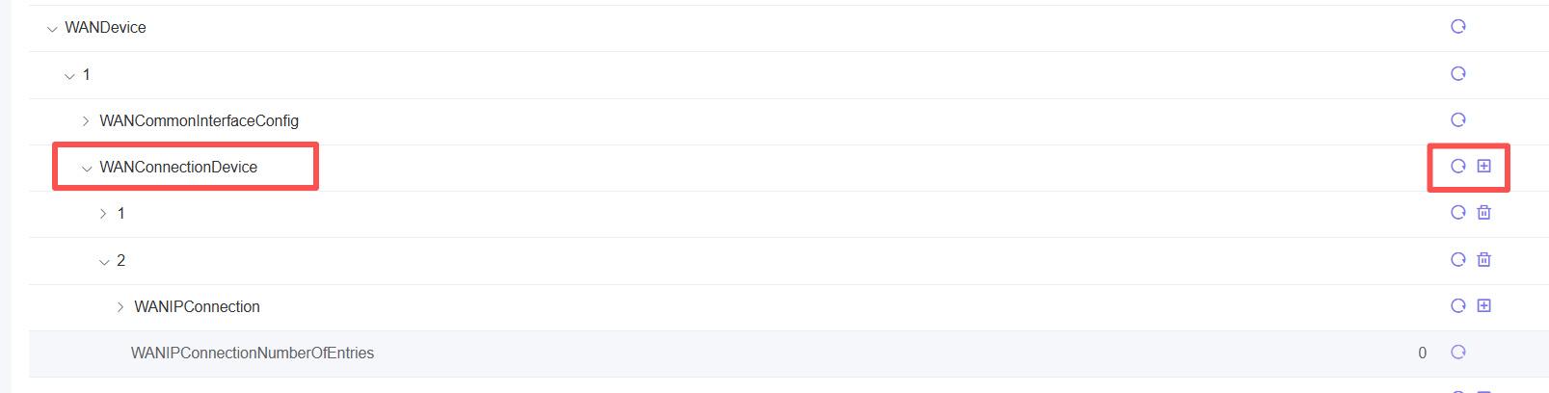
- Configure WAN type:
①PPPOE WAN:
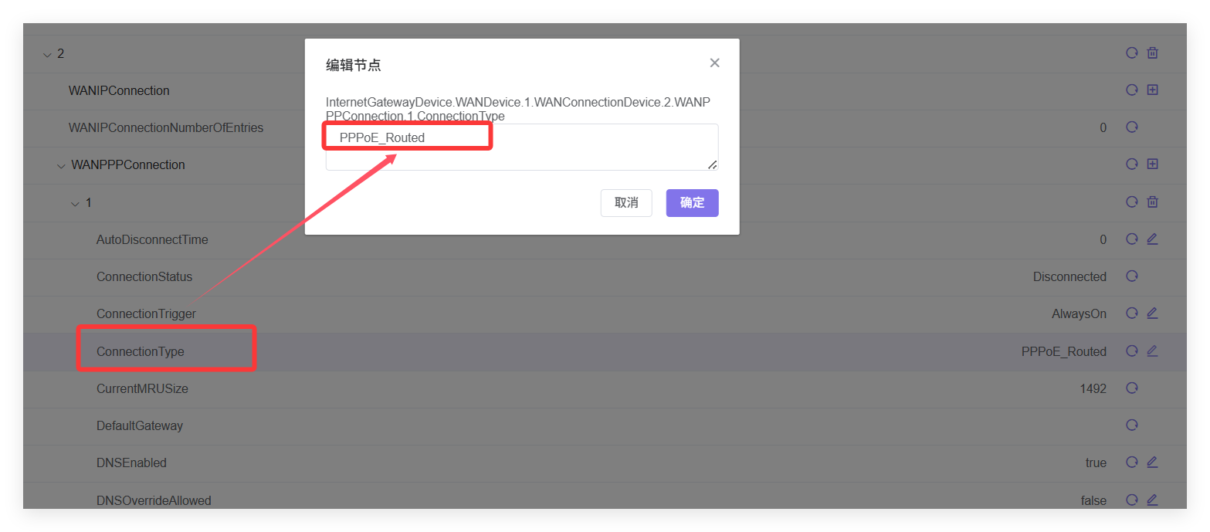
②IPOE WAN:
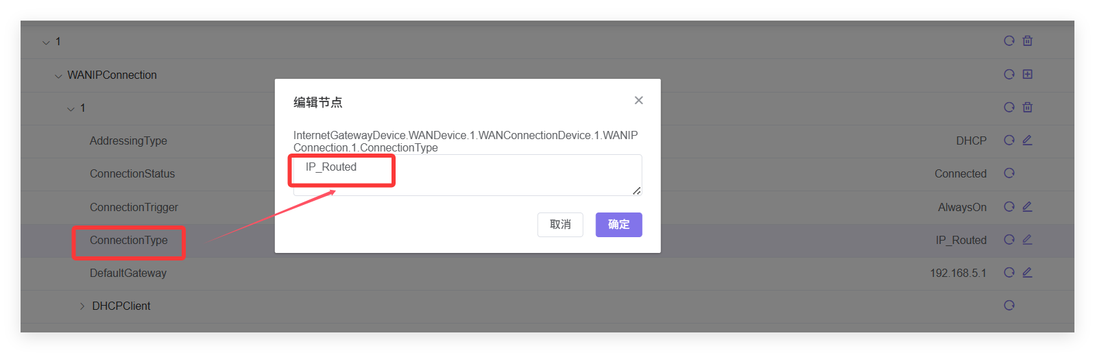
③Bridge WAN:
- Configure WAN to be displayed on the ONU web page:
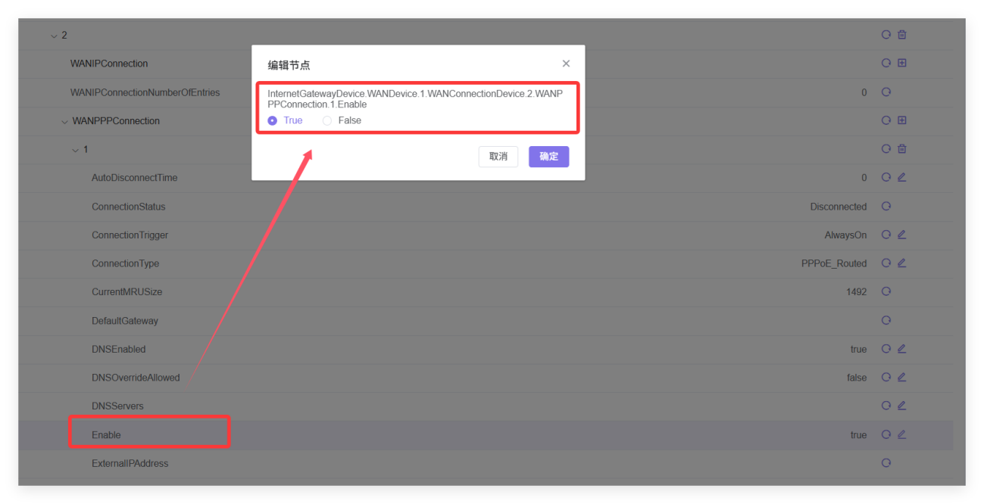
- Configure VLAN: You need to configure vlanmode to 2 before configuring specific VLANs
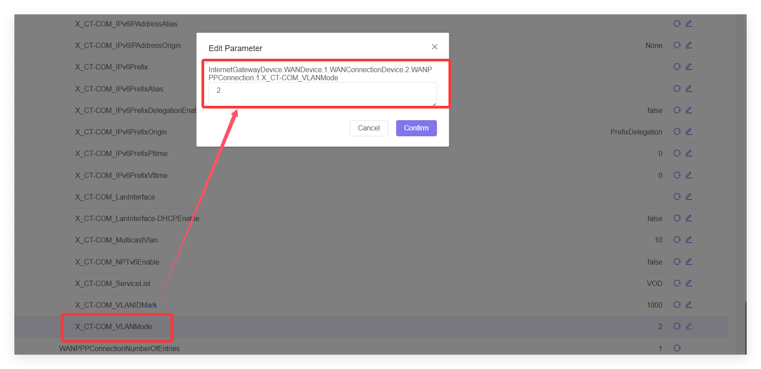
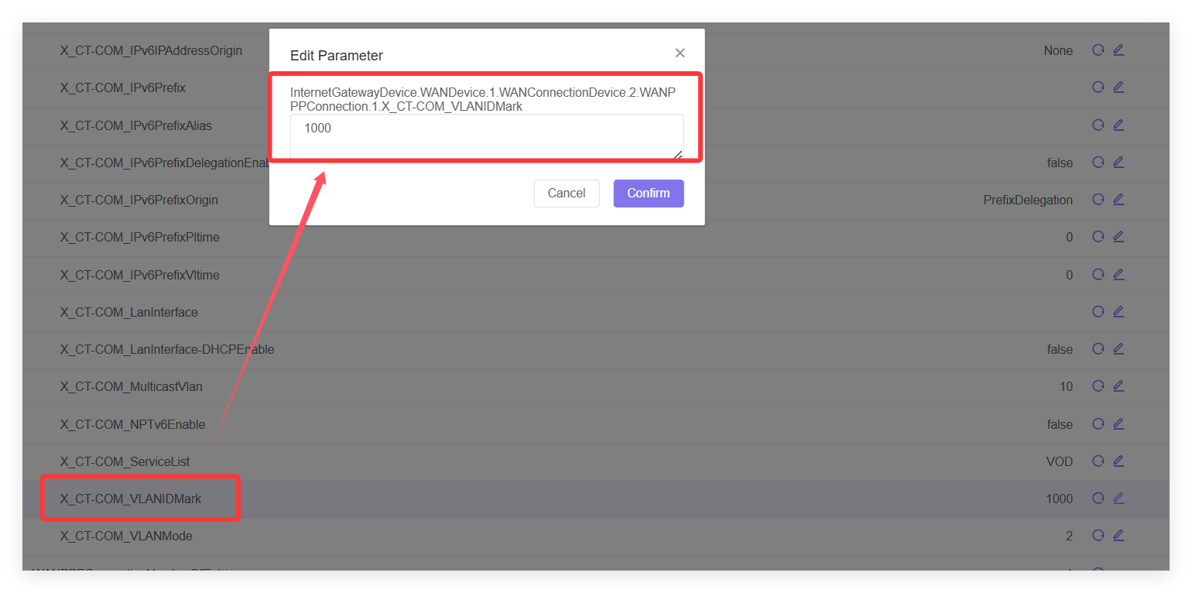
- Configure the WAN service type: VOD is other type;
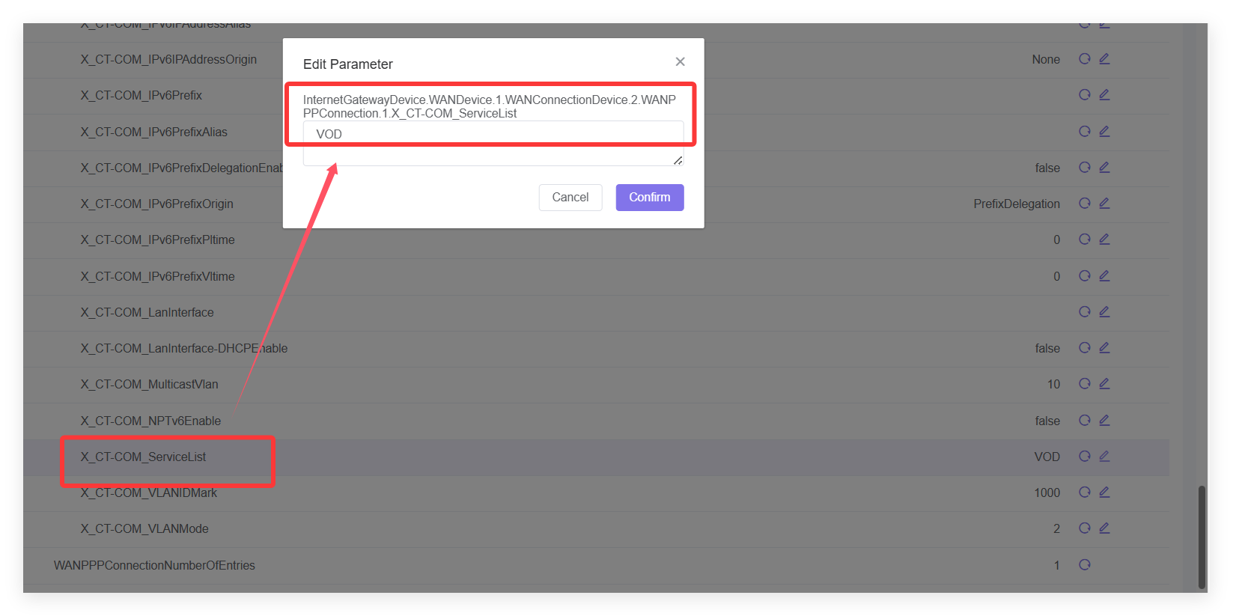
- Configure multicast VLAN: first enable multicast proxy, then configure multicast VLAN (-1 means not configured by default)
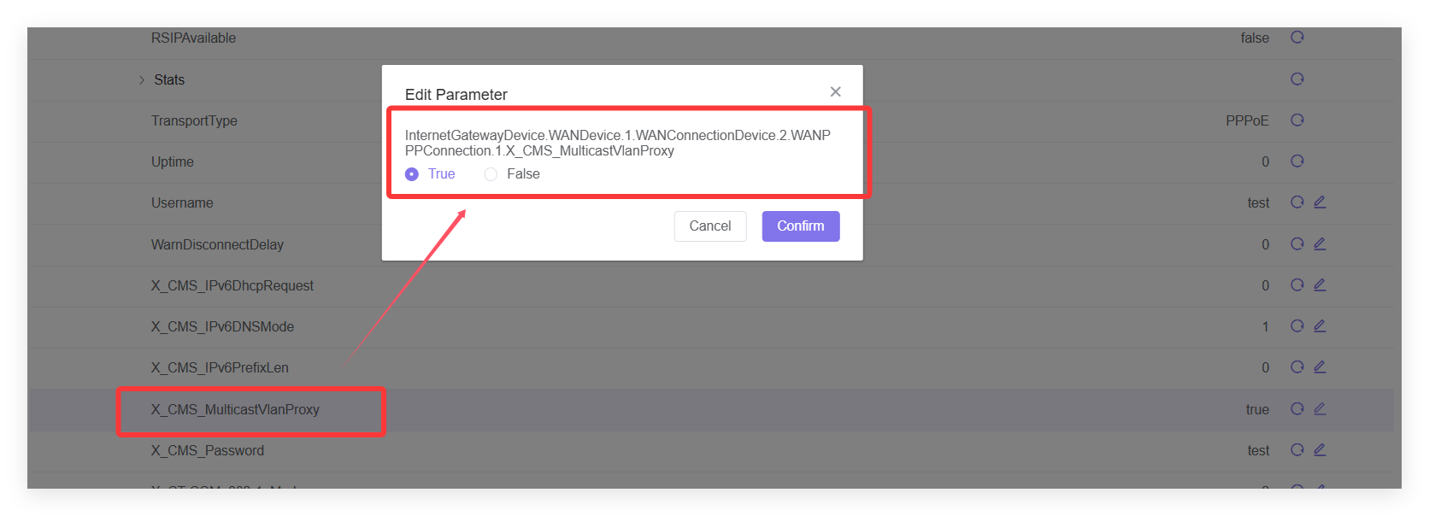
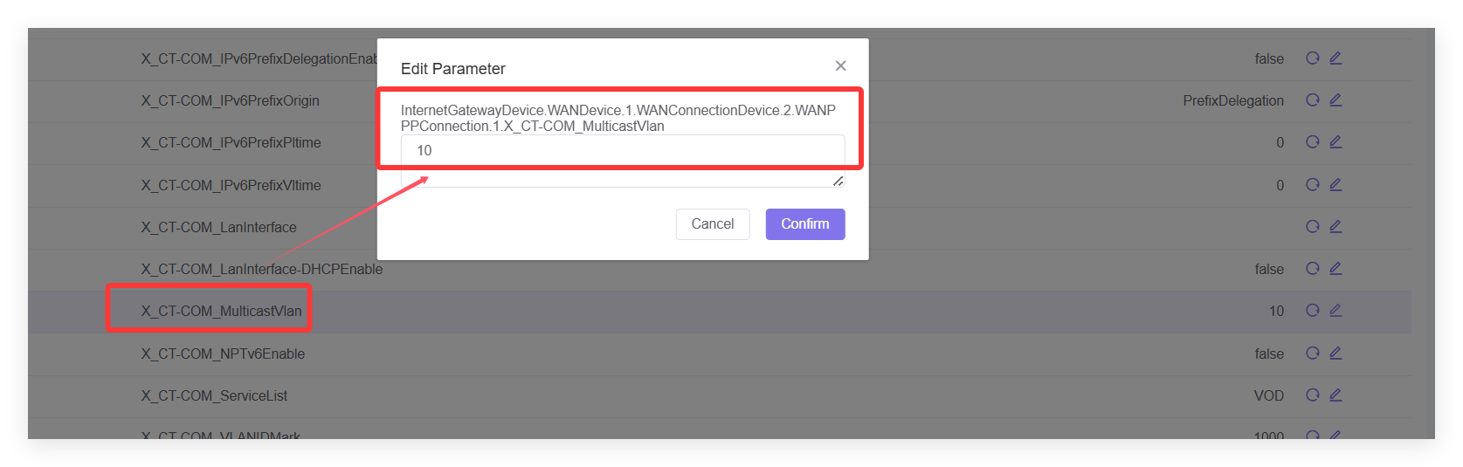
- Turn on NAT
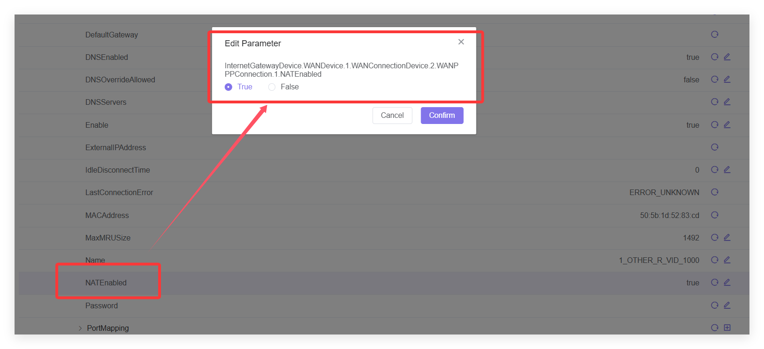
- PPPOE WAN account and password:
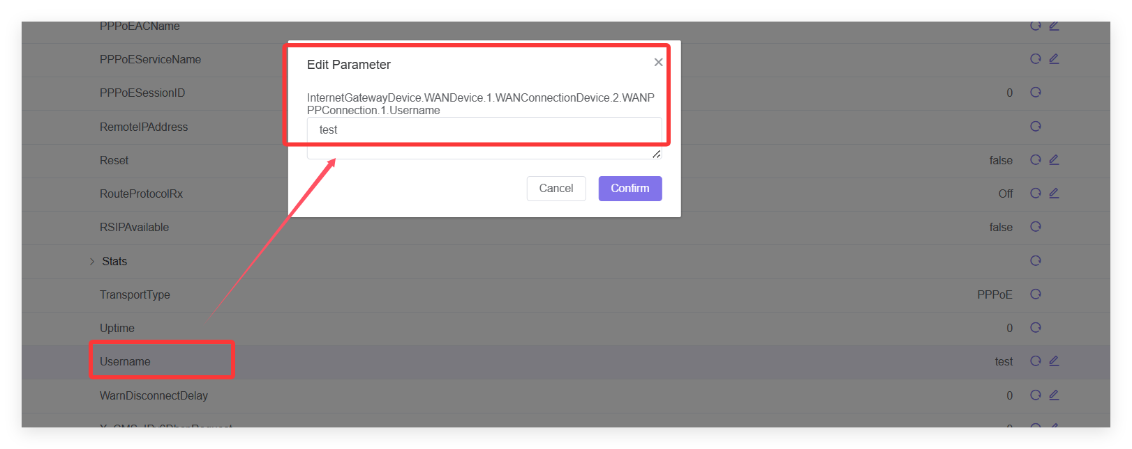
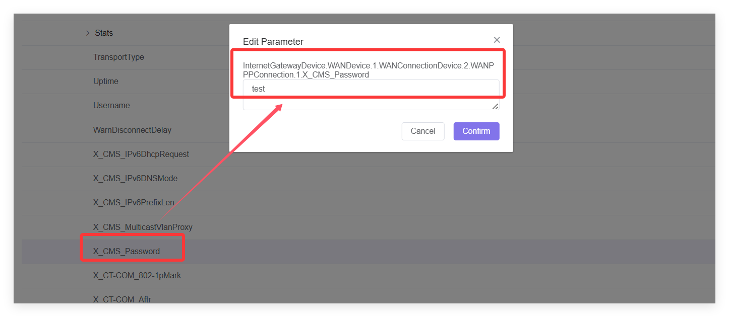
After the configuration is complete, it will be displayed as follows:
